**Department of Electronic & Telecommunication Engineering**

**University of Moratuwa**



**EN2160 - Electronic Design Realization**

**Conceptual Design Report**

**T.L Abeygunathilaka**

**200003P**

# **Introduction**

We acknowledged the significance of incorporating input from the end-users, who are the intended beneficiaries of the laptop cooling pad. To ensure a well-informed decision, we generated three unique design concepts, each with its own approach and potential. In order to gain insights and perspectives from the end-users, we conducted an extensive survey to identify their expectations and requirements. The survey yielded valuable feedback, allowing us to better comprehend their needs and make an informed decision regarding the most suitable design concept for my Laptop cooling pad.

In this report, I aim to present a detailed evaluation of these four designs, taking into consideration aspects such as functionality, usability, manufacturability, cost-effectiveness, and scalability. By examining these criteria, we can ensure that the chosen design not only satisfies the needs of the end-users but also offers a viable solution in terms of production and market viability.

# **List of Members who contributed to the Design-driven Innovation.**

The following is a list of the names and corresponding index numbers of my team members who made valuable contributions to the conceptual design generation.

# D.K.D Dewagiri 200119C

U.J.R Leelananda 200339B

H.H.A.M Haputhanthri 200207U

W.H.P De Silva 200114G

T.L Abeygunathilaka 200003P

K.K.D..Kariyawasam 200289U

# **3. Enclosure Design**

Three specific designs were selected for the review process after a variety of design possibilities were taken into consideration with the goal of finding the best solution.

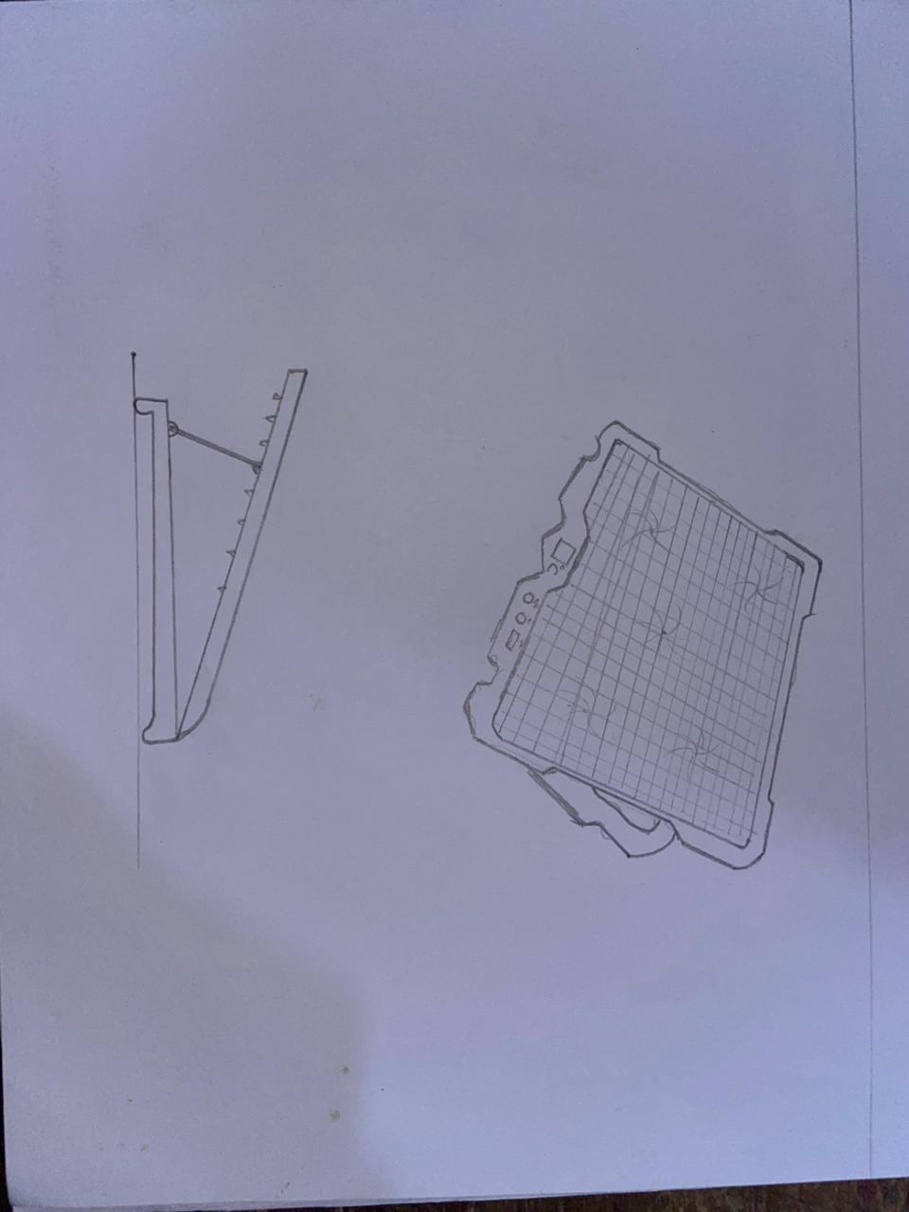Design 1

Design 2

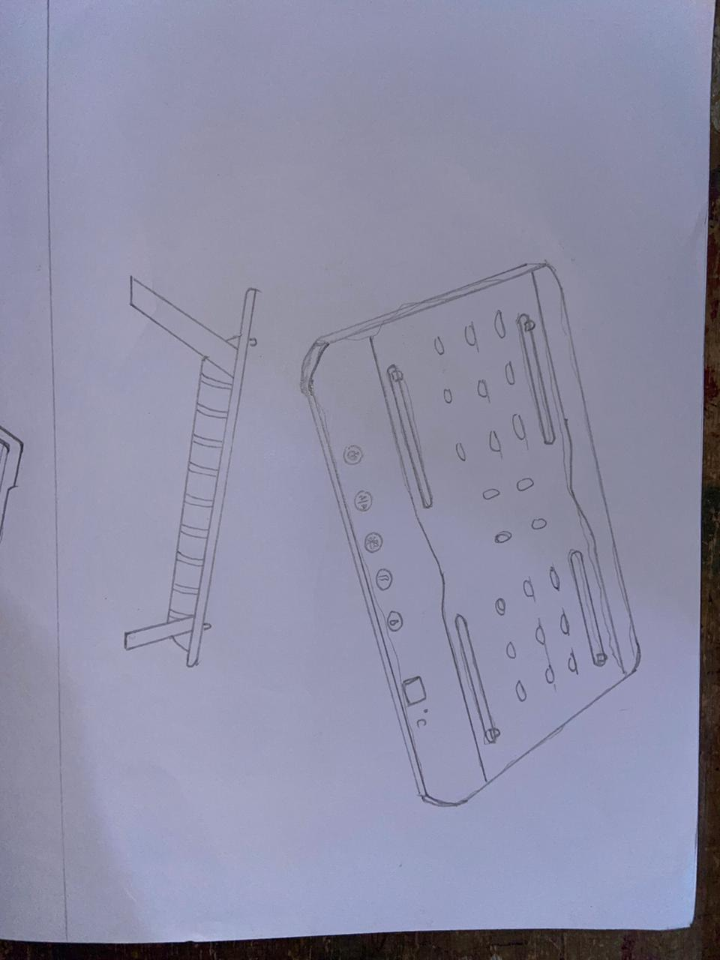

Design 3

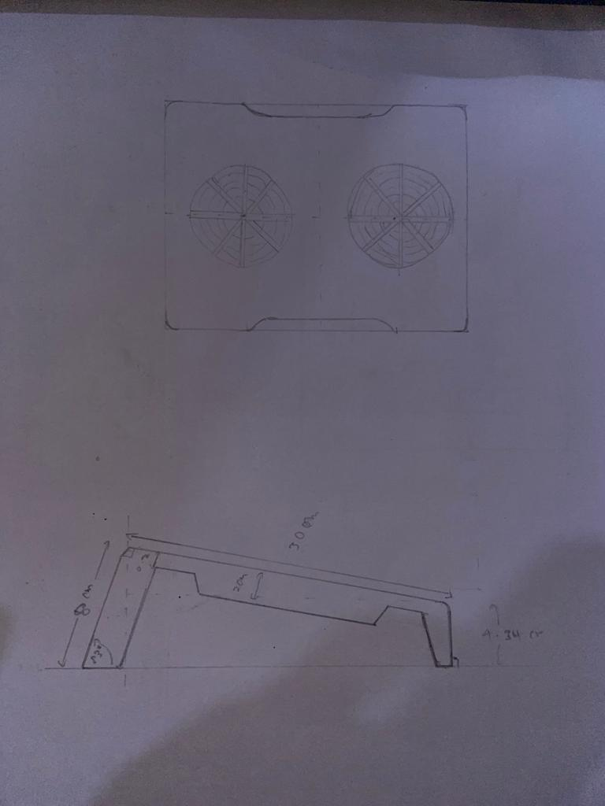

# **4. Functional Block Diagram**

In terms of the digital ruler design, there were 3 main options to consider regarding the enclosures, my team members implemented 3 schematic designs for the above designs.

Design 1

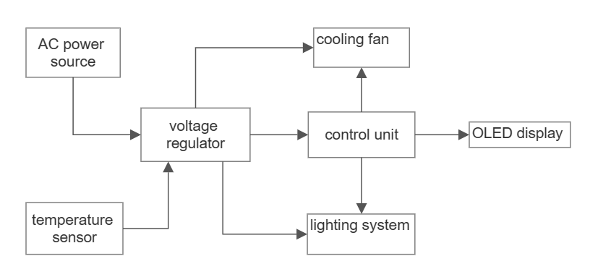

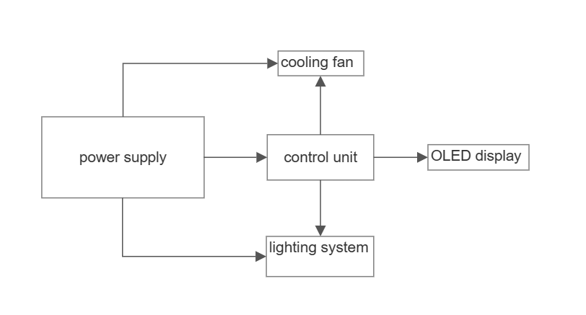Design 2

Design 3

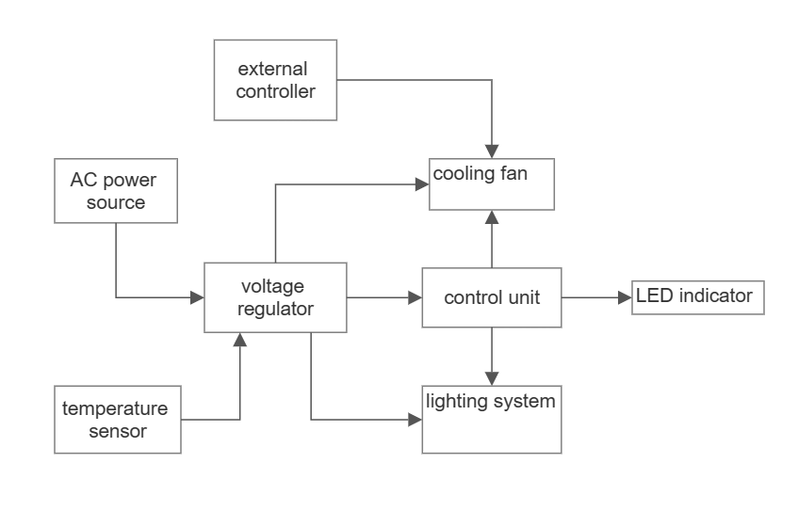

# **5. Modified Designs After User Survey**

**Questions asked in the user survey.**

A lot of the users requested ease of use, portability, durability, and accuracy as main features. Therefore, the below design was implemented considering their expectations.

1. Laptop Overheating: How frequently does your laptop experience overheating issues? How does laptop overheating affect your productivity and comfort? On a scale of 1-5, how concerned are you about laptop overheating?
2. Portability: How important is portability when considering a laptop cooling pad? What is the ideal size and weight for a portable laptop cooling pad? How often do you carry your laptop and cooling pad together?
3. Effectiveness: How satisfied are you with your current laptop cooling solution? What cooling techniques do you think are most effective for a cooling pad? On a scale of 1-5, how much do you expect a cooling pad to reduce laptop temperatures?
4. Noise: How sensitive are you to noise while working? What is an acceptable noise level for a laptop cooling pad? Would you prefer a cooling pad with adjustable fan speeds to control noise?
5. Ergonomics: How important are ergonomic features in a laptop cooling pad (e.g., adjustable angle, wrist support)? Do you experience any discomfort or strain during extended laptop use? What specific ergonomic features would you like to see in a cooling pad?
6. Power Source: Do you prefer a USB-powered cooling pad or one with a built-in rechargeable battery? How important is battery life in a cooling pad if it has a built-in battery? Would you like the cooling pad to have a pass-through USB port for charging other devices?
7. Durability and Build Quality: How satisfied are you with the build quality of your current cooling pad (if applicable)? What materials would you prefer for a cooling pad in terms of durability and aesthetics? How long do you expect a cooling pad to last before needing a replacement?
8. Compatibility: What size laptop do you primarily use (e.g., 13-inch, 15-inch, 17-inch)? How important is it for the cooling pad to be compatible with different laptop models? Would you like the cooling pad to have adjustable arms or supports for better compatibility?
9. Additional Features: How interested are you in cooling pads with additional features like LED lighting or USB ports? Would you like the cooling pad to have adjustable fan speeds for better customization? Are there any other features you would like to see in a laptop cooling pad?
10. Price Range: What is your expected price range for a laptop cooling pad? What factors would justify a higher price for a cooling pad? Would you be willing to invest more in a cooling pad if it offered advanced cooling technology?

## **5.1. Enclosure (Design 4)**

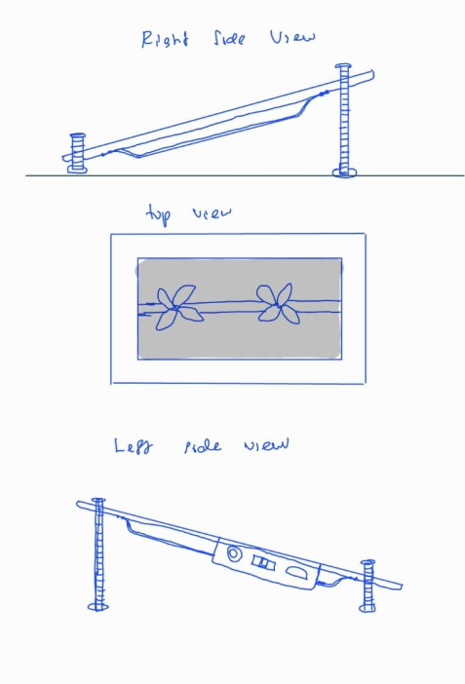

## 

## **5.2. Functional Block Diagram (Design 4)**

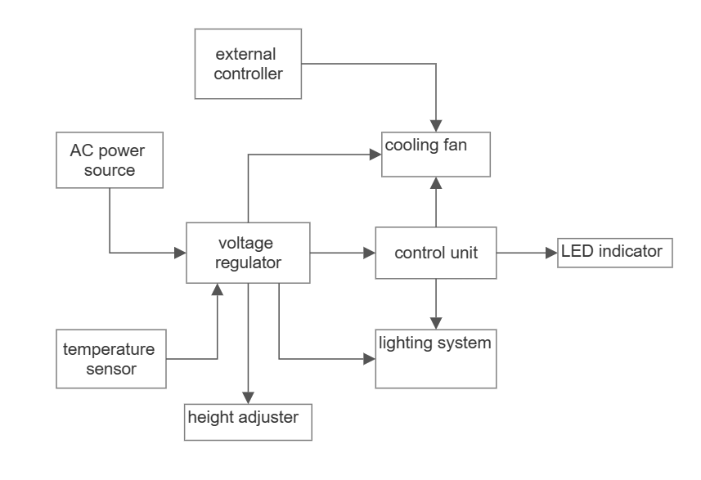

# **6. Selection Matrices**

|  |  |  |  |  |
| --- | --- | --- | --- | --- |
| **Criteria** | **Design 1** | **Design 2** | **Design 3** | **User survey design** |
| Functionality | 7 | 7 | 7 | 8 |
| User Experience | 5 | 6 | 7 | 9 |
| Precision and Accuracy | 7 | 6 | 8 | 9 |
| Data Visualization | 7 | 7 | 7 | 7 |
| Data Storage and Sharing | 8 | 7 | 7 | 9 |
|  |  |  |  |  |
| Durability and Reliability | 8 | 7 | 8 | 9 |
| Cost-effectiveness | 5 | 5 | 7 | 8 |
| Power Efficiency | 5 | 4 | 8 | 9 |
| Aesthetics and Design Appeal | 6 | 6 | 8 | 9 |
| Feasibility | 5 | 5 | 7 | 8 |
| **Total** | **63** | **60** | **74** | **85** |

# **7. Selected Design**

According to the above results Design 4, which was implemented considering user input, has got 81 marks out of 100 (10 criteria 10 marks per each). Therefore, the **selected design is Design 4**.